INFORMATION AND ANALYTICAL CENTRE
OF FSUE “GosNII GA”

Aircraft component authenticity evaluation method

No. 24.10-966GA

TECHNOLOGICAL INSTRUCTION
FOR PHOTOGRAPHIC RECORDING OF MAINTENANCE RECORDS AND LOG BOOKS DOCUMENTATION AND INDIVIDUAL LABELS OF AIRCRAFT COMPONENTS
24.10-966GA-2

Moscow
2017

Table of Contents

p.
- INSTRUCTION DESIGNATION 3
- TECHNICAL REQUIREMENTS 4
- PREPARATORY WORK 5
- WORK PERFORMANCE TECHNOLOGY 7
- CREATION AND SENDING OF ELECTRONIC
MAINTENANCE RECORDS AND LOG BOOKS
DOCUMENTATION IMAGE DATABASE 11
- APPENDIX 16

- Instruction designation

This technological instruction (hereinafter - “the Instruction”) is an integral part of the aircraft component authenticity evaluation method No. 24.10-966ГА (hereinafter -” the Method”) used during works in accordance with the Method.

The instruction is intended to be used to create the database of digital maintenance records and log books documentation images and unit assembly and part labels, as well as separate aircraft components and its subsequent sending to the IAC FSUE “GisNII GA”.

This Instruction sets the following:

the order of photographic recording of maintenance records and log books documentation and labels of unit assemblies and parts;
- the order of preparation for and sending of digital photos of maintenance records and log books documentation and labels of unit assemblies and parts to insert data to CDB of IAC FSUE “GosNII GA”.

The Instruction is to be used by airline companies, industrial companies and ARF engaged in aircraft component authenticity evaluation.

Photos of maintenance records and log books documentation and labels of unit assemblies and parts are made by airline company specialists, who underwent relevant training in an established order.

Technical means used to take photos of maintenance records and log books documentation and labels of unit assemblies and parts should meet the requirements given in section 2 hereof.

Technical requirements
  - Digital cameras should be used to take photos of maintenance records and log books documentation and labels of unit assemblies and parts.
  - Digital cameras should be able to directly connect to the computer and insert digital video information to it. It also should be able to be mounted on a tripod.
  - Recommended computer and software configuration:
- processor performance - 32 (x86) or 64 (x64) bit processor with 1 GHz or higher clock speed;
- RAM - 1 GB (recommended - 2 GB and more);
- Internet access with 256 Kb/sec and higher capacity;
- email;
- Internet access software:
- Browsers: Mozilla Firefox, Google Chrome or Internet Explorer, at least of version 10;
- Mail client: any actual mail client;
- graphic image processing software (for example, ACDSee, XnView, etc.);
- data archiving software – recommended program is ImageConverterSetup. It or any other contemporary data archiving software may be downloaded at http://obmen.mlgvs.ru/,;
- Windows XP with 3 update pack and higher.
  - Digital cameras should meet the following requirements:
- guaranteed image resolution – at least 1280 х 960 pixels;
- general amount of matrix pixels - at least 1,23 million pixels;
- optic zoom – at least 2 times;
- automatic and manual focus modes;
- sensitivity as per ISO – at least 100 units;
- digital input/output, interface (USB) or wireless;
- ability to be mounted on a tripod;
- flash.

Preparatory work
  - Before taking photos of maintenance records and log books documentation and labels of unit assemblies and parts, a list of aircraft components, maintenance records and log books documentation and labels of which are to be captured, is determined. Sections (pages) of maintenance records and log books documentation to be captured are also chosen. A list of aircraft components to be captured should correspond to the aircraft components formed in the exchange file and include aircraft components with limited resources and service life, as well as maintenance records and log books documentation copies.
Note: There are two versions of the exchange file: interactive version - web application (recommended) available at https://ias.mlgvs.ru/resources/ and an Excel file, the template of which may be downloaded at http://mlgvs.ru/autent.html
  - A sequence of shooting of sections (pages) of maintenance records and log books documentation should correspond to their numbering.
  - Before taking photos of maintenance records and log books documentation and labels of unit assemblies and parts the following data is captured:
- name of the airline company operating (owning) the aircraft, the maintenance records and log books documentation of which is to be captured;
- aircraft type;
- on-board (plant) aircraft number;
- date of shooting;
- the photographer.
The data should be written down on a blank paper and captured (Fig. 1).
  - Before taking photos of maintenance records and log books documentation and labels of unit assemblies and parts, the following data should be captured:
- name of the airline company taking photos of the documentation;
- date of shooting;
- the photographer.
The data should be written down on a blank paper with a mark “STORAGE” (Fig. 2).

AIRLINE COMPANY “….”

AIRCRAFT TYPE ………

On-board No. ……..

Date of shooting __.__.__

The photographer
… (position, full name)

STORAGE

“……..”

Name of the airline company
)
(

Date of shooting __.__.__

The photographer… (position, full name)

Fig. 1 Fig. 2

Work performance technology
  - Photos should be made in a closed premise providing security to captured objects and the best shooting quality. The captured object (maintenance records and log books documentation) should be placed on an equally lit, flat and horizontal surface with a matte finish.
  - Recommendations on lighting selection
- artificial lighting should not flash and reflect on the captured object;
- while using backlight, place it so that the object is equally lit;
- it is not recommended to use powerful lighting, since image quality gets worse.
  - Shooting sequence.
    - Open the case and take the camera from it.
    - Mount the camera on a tripod so that it is possible to take photos of the horizontally placed object.
    - Uncover the lens and activate the camera in accordance with its operating manual.
    - Make sure that camera settings and standard digital media memory volume enable qualitative shooting of the necessary amount of labelled parts and their maintenance records and log books documentation.
    - Adjust the camera so that the captured object (a section or a page of maintenance records and log books documentation) completely gets into frame.
    - To ensure desired image quality, the shooting mode set should be at least 1280 х 960 pixels and maximum 5 megapixels.
    - Ensure that foreign objects (tripod legs, lens cover, etc.) do not get into the frame.
    - Smoothly press the release button trying not to swing the camera, when the shutter activates. Pushing of the release button may worsen image sharpness.
    - Connect the camera to the computer and transfer data to the hard disk.
    - After shooting close the lens and put the camera into the case.
  - Requirements on data sheet shooting.
    - Shooting of the data sheet's title page and pages of the following sections is mandatory:
- “Resources, service and shelf lives”;
- “Preservation and depreservation”;
- “Acceptance certificate”;
- “Movement of operation product”;
- “Repair and performance of the work on bulletins and instructions”.
Note: Sections above and the section “Verification control results” of pumps NP-89 (NP-43) and their modifications should be captured.
    - If there are pages inserted to the data sheet, they should be captured from both sides.
    - Apart from the pages, listed in clauses 4.4.1. and 4.4.2., pages with records (marks) should be captured.
  - Requirements on label shooting
    - All pages of the label should be captured.
    - If there are pages inserted to the label (sections, insertions continued), they should be captured from both sides.
  - Requirements on shooting data sheet (label) copies.
    - Data sheet (label) copies prepared by the manufacturer should be captured in accordance with clauses 4.4 and 4.5 hereof.
    - While shooting data sheet (label) copies prepared by the airline company, the following requirements should be met.
- Shooting of the title page and the certificate “On preparing copies” drawn up by the airline company's committee is mandatory.
- Shooting of all copied pages with records (marks) is mandatory.
- If there are pages inserted to the copy, they should be captured from both sides.
Example of a captured data sheet:

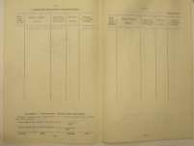

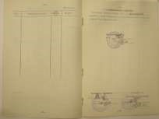

  - Requirements on engine form shooting.
Shooting of the following is mandatory:
- title page;
- section 4 (4.1) “Complexity”;
- section 4.2 “Spare parts…”;
- “Resources, service and shelf lives”;
- “Preservation and depreservation (the last records)”;
- “Acceptance certificate”;
- “Movement of operation product”;
- Section “Work registration (the last records)”;
- “Repair and performance of the work on bulletins and instructions”;
- the last page of the form “Numbered pages and sealed sheets in total” and seal.
  - Requirements on aircraft form.
- title page;
- section 4.1, “Unit complexity and changes to assembly”;
- “Resources, service and shelf lives”;
- “Preservation and depreservation (the last records)”;
- “Acceptance certificate”;
      - “Movement of operation product”;
      - section “Work registration (the last records)”;
      - “Repair and performance of the work on bulletins and instructions”;
      - the last page of the form and the seal.
  - Places of shooting of separate aircraft component industrial labels for their subsequent verification at manufacturer's are given in the Appendix 1 hereof.

Creation and sending of electronic maintenance records and log books documentation image database

Creation of maintenance records and log books documentation digital photo and unit assembly and part label database. The structure of assigning names to database elements for data sheets of the units operated on aircrafts is created in the following way (Fig. 3).
- name of the airline company;
- aircraft type;
- date of shooting;
- on-board aircraft number;
- drawing number of unit;
- plant number of unit.

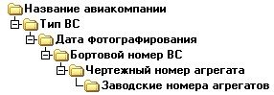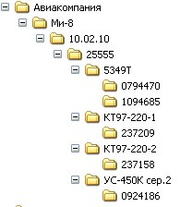
Airline company
YC-450K.ed.2
Mi-8
Plant number of unit
Name of the Airline company
Type of aircraft
Date of shooting
On-board aircraft number
drawing number of Unit
Fig. 3

The structure of assigning names to database elements for data sheets of stored units (Fig. 4).
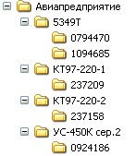
Plant number of unit
Drawing number
Name of the airline company
YC-450K.ed.2
Airline company

Fig. 4

Placement of digital images of maintenance records and log books documentation in ACDSee.
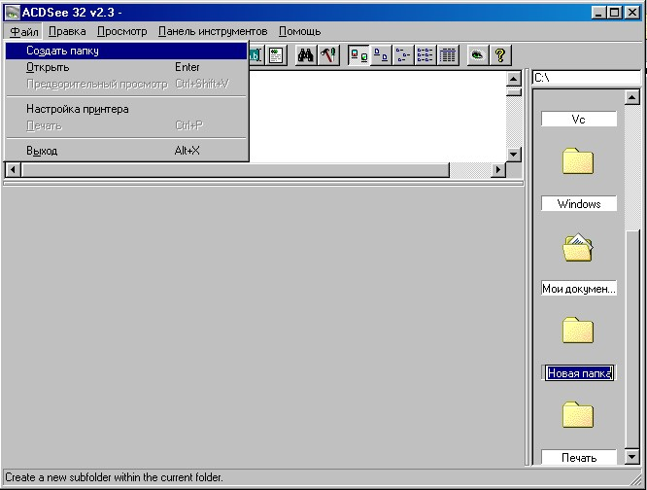
New folder
File Edit View Tools Help
My docum…
Exit
Print
Printer setup
Preview
Open Enter
Open folder

2

3

1
Fig. 5

After cl. 4.3.9. According to the instruction, captured documentation should be put into separate folders in any digital image viewing and editing software, for instance, IrfanView, ACDSee or similar software.
      - Use of ACDSee is shown below as an example.
      - Open two ACDSee windows (Fig. 6).
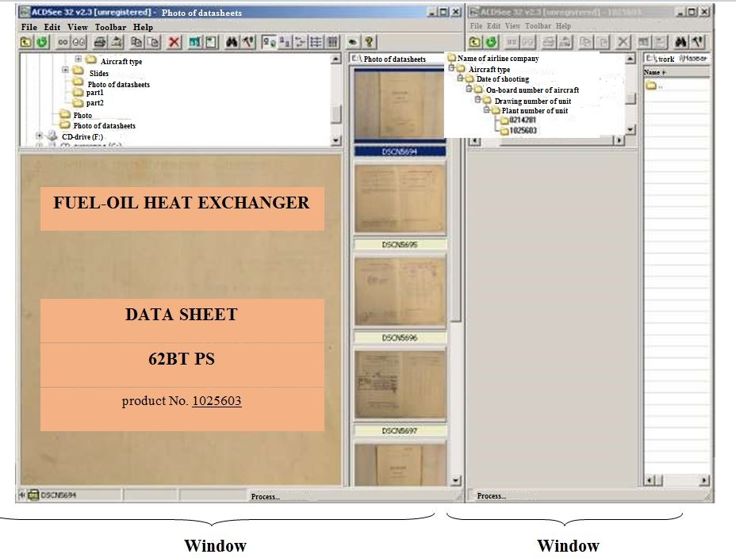
2
1
Fig. 6
      - In the first window, enter the folder with the photos of data sheets moved from the digital camera and place icons in the order by name (choose “View” in the menu, then choose the “Arrange icons” command; after that choose “Icons by name” parameter) as shown on Fig. 7.
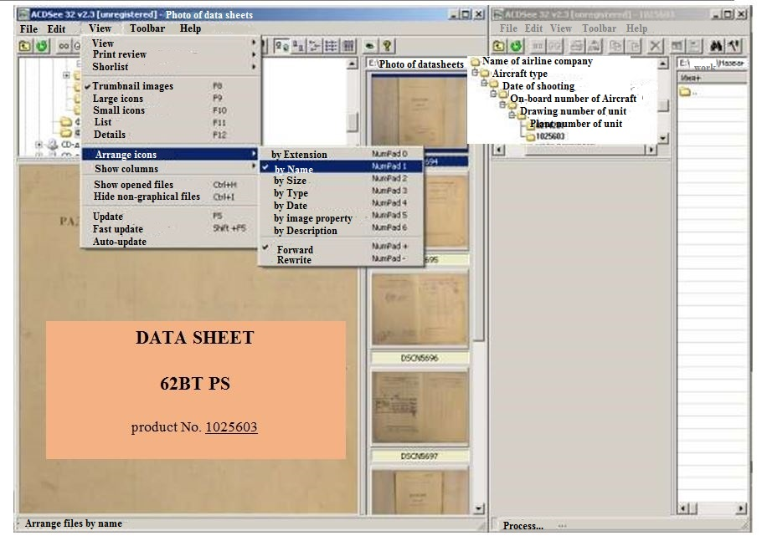
Fig. 7
      - In already prepared structure of the database (see cl. 5.1) of the second window, create a folder and give it a number corresponding to the unit plant number; in this case, the number is as shown on Fig. 6.
      - In the first window, highlight all captured unit data sheet and its labelling pages (press the first data sheet page, which will be chosen by mouse button, and hold SHIFT pressed, then press the last data sheet page with the mouse). After that move the data sheet pages selected to the created folder in the second window; in this case, it is the folder . Similarly, in the folder with aircraft on-board number, create the necessary number of folders with numbers of data sheet units and their industrial labels.
While shooting industrial labels of the unit, put photos of the labels in the folder with captured data sheet of this unit.

  - Transfer of digital images of maintenance records and log books documentation and labels of unit assemblies and parts.
To transfer created list of digital images of maintenance records and log books documentation and labels of unit assemblies and parts via Internet, they should be packed with image packing software, which can be downloaded at http://obmen.mlgvs.ru/. Unlike an ordinary archiving software, this software reduces the size of photos to the size necessary to review and print the minimum number of photos.
To send the files to the information and analytical center FSUE “GosNII GA” through the Internet, use special file exchange service at http://obmen.mlgvs.ru/.
In extreme cases, if the service is unavailable, the files may be sent via email at ias@mlgvs.ru, but the files should be separated into parts of 7 Mb each (the maximum message size of some mailing servers may be higher).

Appendix 1
Technological instruction for shooting separate industrial aircraft labels
- Mi-8 type aircraft.
  - While evaluating authenticity of Mi-8 type aircraft transmission components, in accordance with the manufacturer’s requirements, electronic photos of separate part labels of the following units put on them in the form of combination of letters and numbers should be provided:

for the main gearbox VR-14:
- gear housing;
- pallet;
- front cover;
- screw shaft cover;
- screw shaft housing;
- fan drive cover.

for the swashplate:
- plate 24-1940-720;
- flat spot 24-1940-501;
- flat spot guide 24-1940-204;
- bracket 24-1940-102;
- left handle cheek 8-1950-111;
- right handle cheek 8-1950-112;
- bracket 24-1940-511.

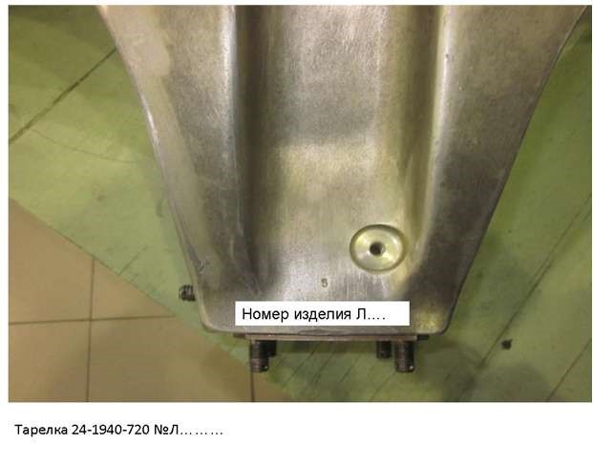
Plate 24-1940-720 No. L…..
Part number L…..
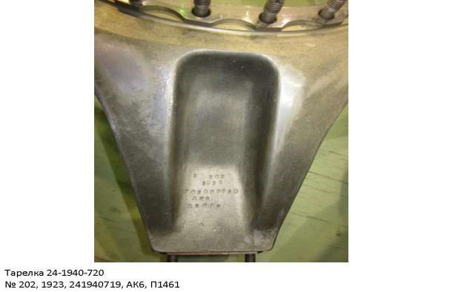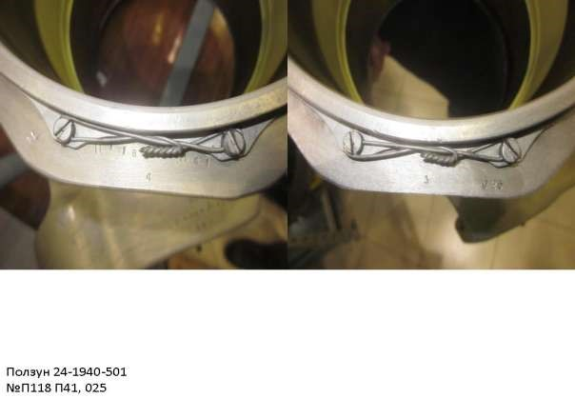
Plate 24-1940-720
No. 202, 1923, 241940719, AK6, P1461

Slider 24-1940-501
No. P118 P41, 025

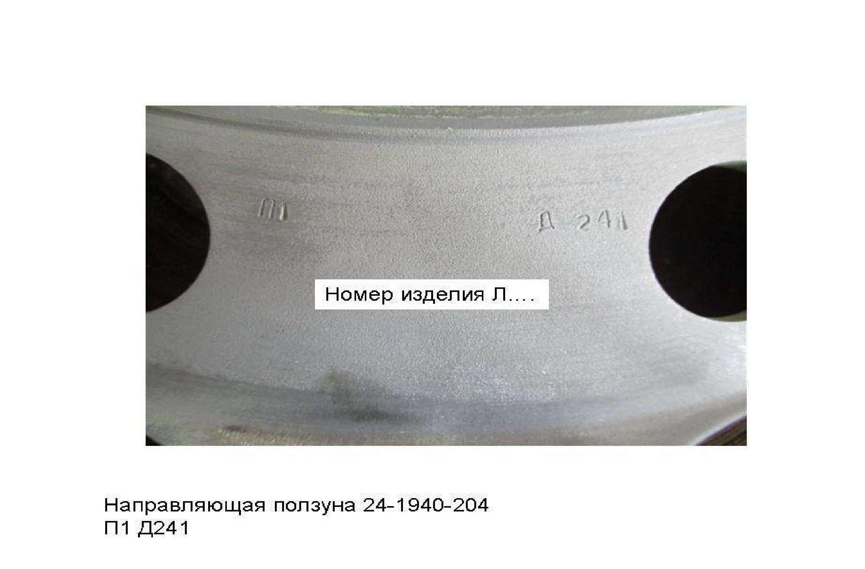
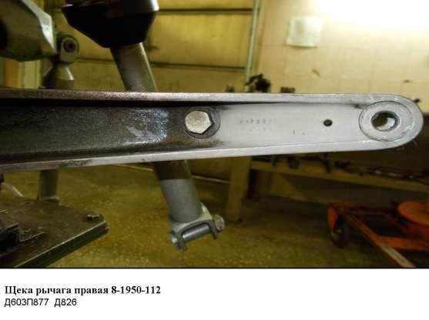
Slider guide 24-1940-204
P1 D41
Part number L…..
Right cheek handle 8-1950-112
D603P877 D826
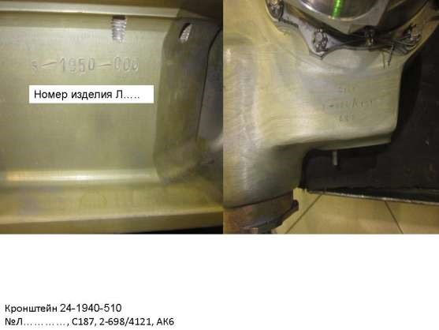
Bracket 24-1940-510
No. L ........, 2-698 / 4121, AK6
Part number L…..

for the tail shaft:
- hinge 8А-1516-20;
- middle hinge 8А-1516-30.
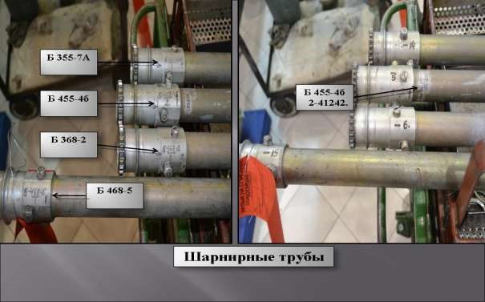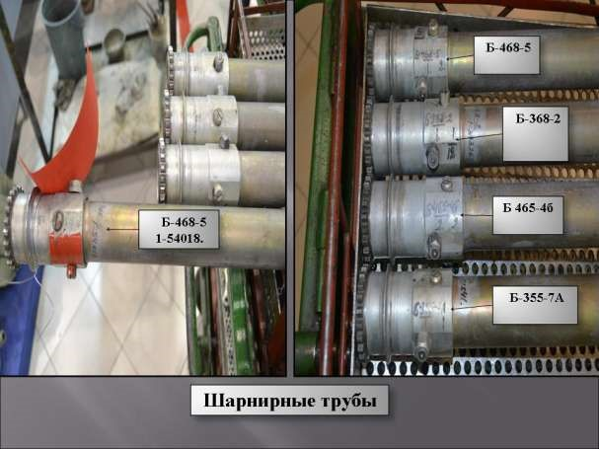
Hinged pipes
Hinged pipes

To access the individual production labeling of the tail shafts 8A-1516-000, it is necessary to flush the paintwork with subsequent restoration of the coating.

for the intermediary gear:

- crankcase 8А-1515-352;
- driven gear tumbler 8А-1515-270;
- slave gear tumbler 8А-1515-170 .
If the product is assembled, then electronic photos of individual production markings of the crankcase 8A-1515-352 are provided.

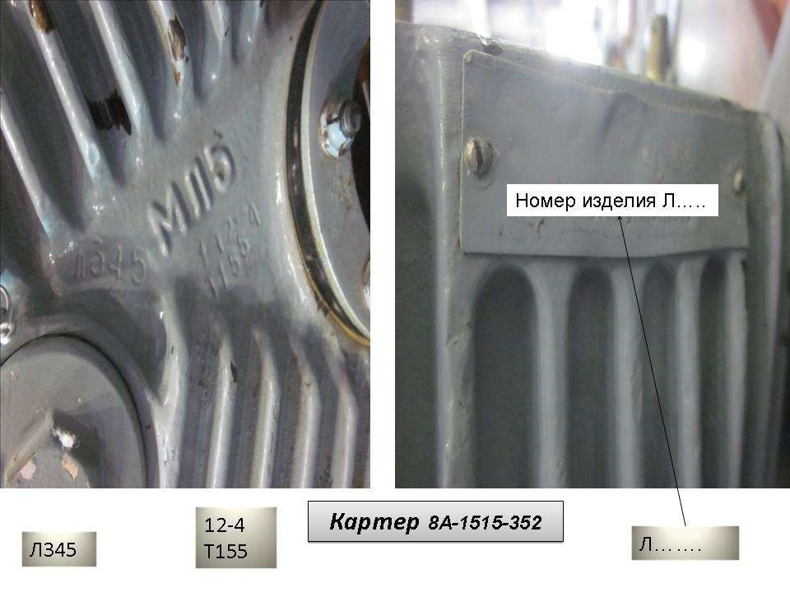
Case 8A-1515-352
Part number L…..
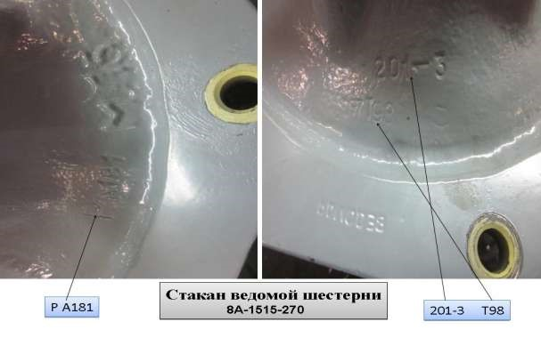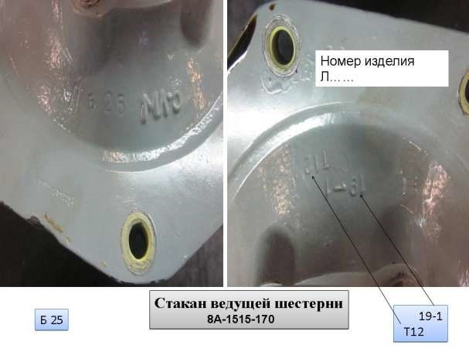
Part number L…..
Drive gear tumbler
Drive gear tumbler

for the tail gear:
- crankcase 8А-1517-300;
- crankcase cover 246-1517-260;
- slave shaft 246-1517-251;
- driven gear joint 8А-1517-218;
- slave gear 8А-1517-218;
- driven gear tumbler 8А-1517-101;
- drive gear 8А-1517-101.
If the product is assembled, then electronic photos of individual production markings of the crankcase 8A-1517-300 are provided.

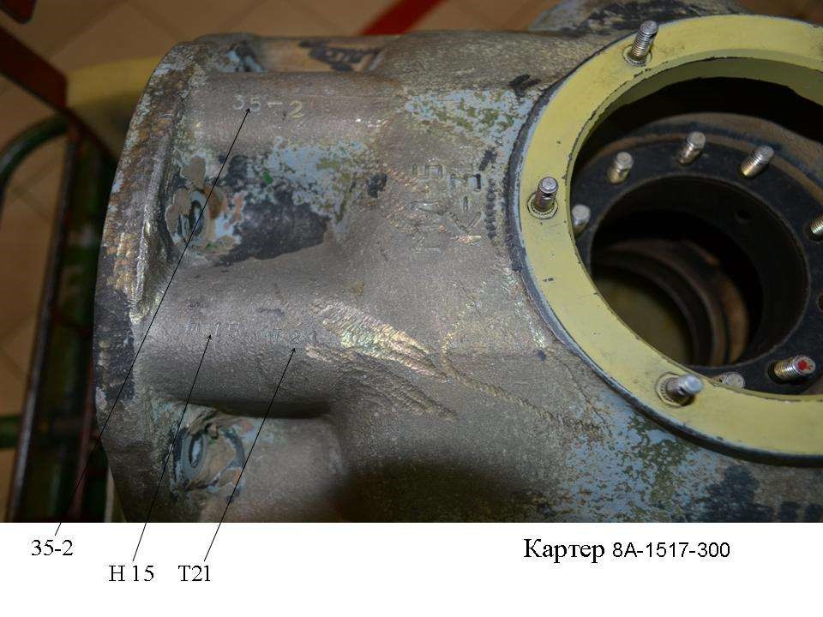
Case 8A-1517-300
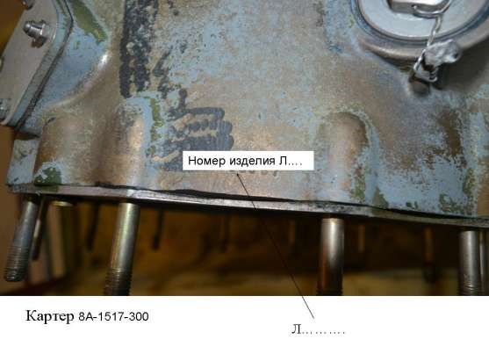
Case 8A-1517-300
Part number L…..

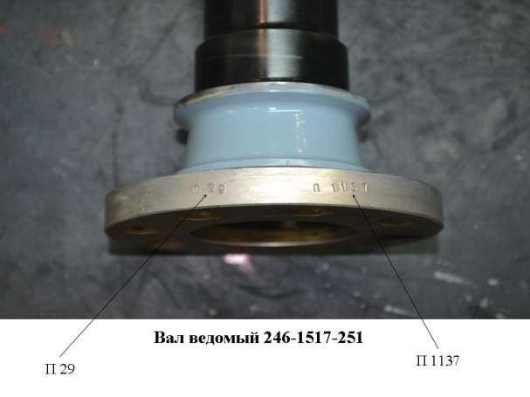
Slave shaft 246-1517-251
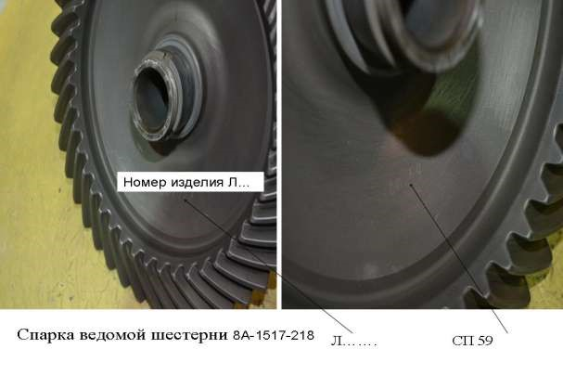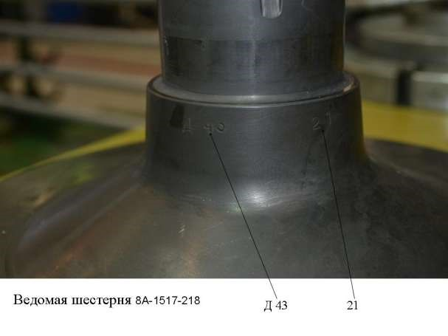
Slave gear 8A-1517-218 D 43 21
Slave shaft joint 8A-1517-218 L….. SP.59
Part number L…..
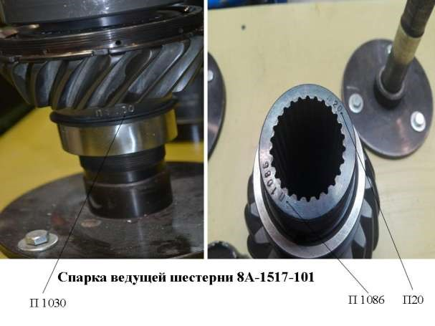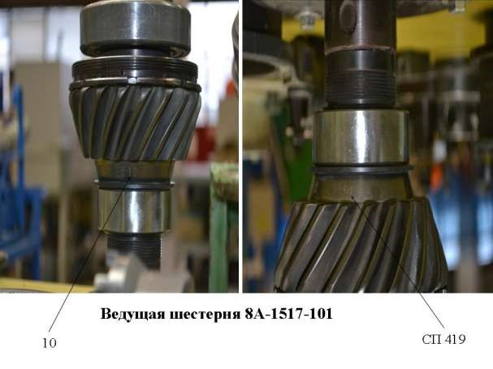
Drive gear 8A-1517-101
Drive gear joint 8A-1517-101
  - To evaluate the authenticity of the 8АТ-2710-000 rotor blades, information on numbers of tips, longerons and pressure signaling devices mounted on the blades should be provided in tabular form (see Table 1) (Photos are not necessary).

Table 1
8АТ.2710.000 No. | Signaling device No. | Longeron No. | Tip No.

  - To evaluate the authenticity of the main chassis 8А-4101-00B shock absorber, electronic number label photos of the tripod should be provided:
- 8А-4101-100 – cylinder;
- 8А-4101-70 – cylinder;
- 8А-4101-50 – stock.
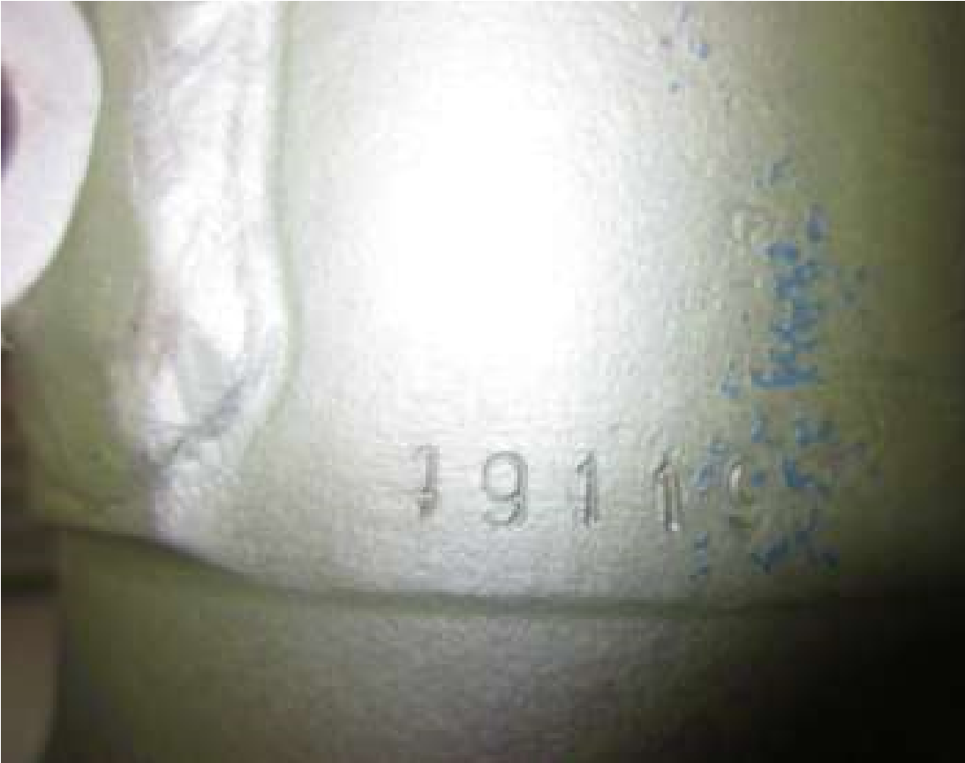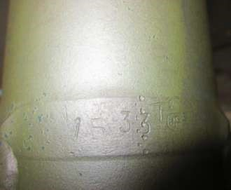

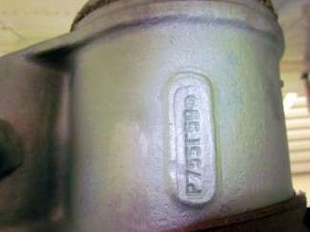 | 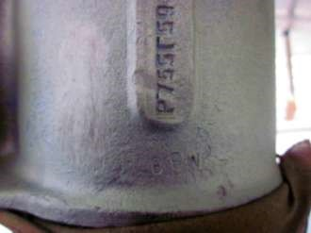

To assess the authenticity of the front chassis suspension arm rack
8A-4201-00A, it is necessary to provide electronic photos of markings of product numbers included in the rack:
- 8A-4201-150/200 - lever;
- 8A-4201-50A - cylinder;
- 8A-4201-170A/160A - bracket.
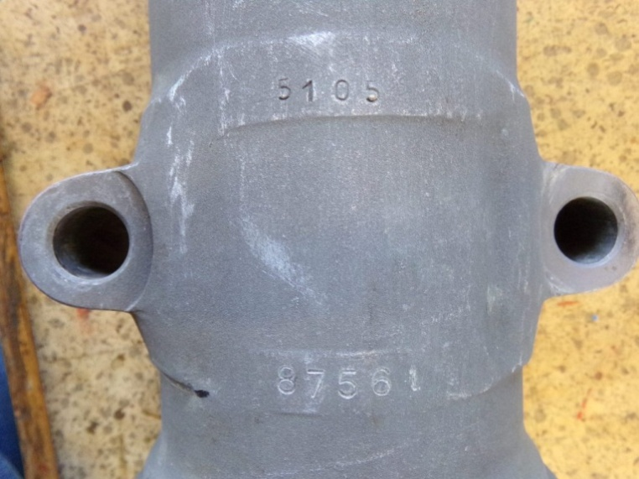 | 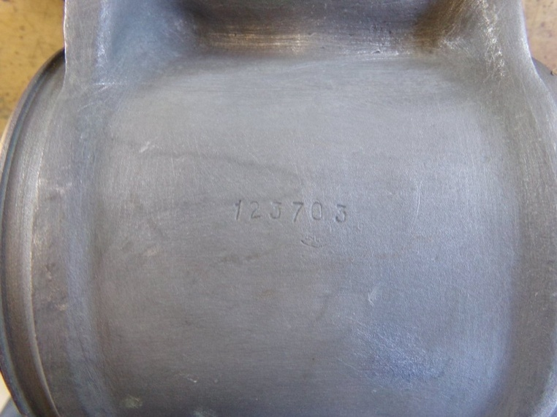
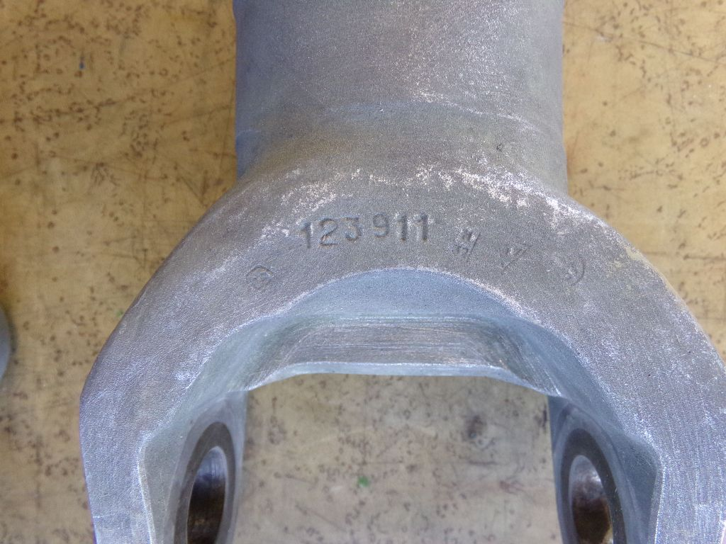 | 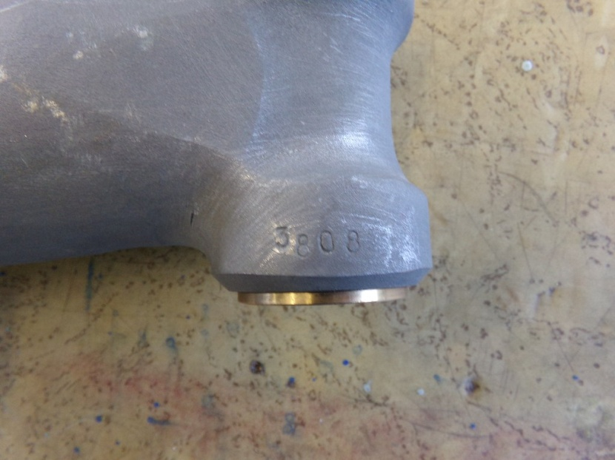

1.4 To evaluate the authenticity of КАУ-30B, КАУ-115АМ and РА-60B, their color photos should be provided, in particular:
- factory label;
- case, cylinder and other parts with images of technological numbers.

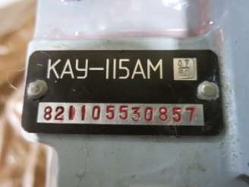 | 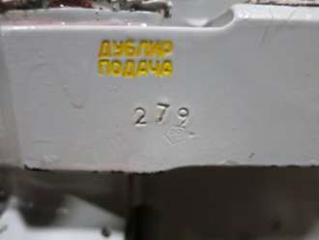
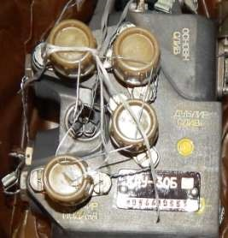 | 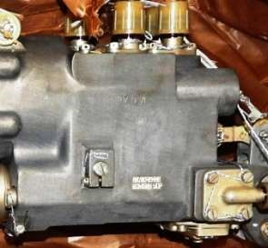

  - To evaluate the authenticity of the fan 8А-6311-00, numbers of smelters on the straightener 8А-6311-15 or photos with numbers of smelters should be provided.

  - To evaluate the authenticity of rotor bushes 8-1930-00, data should be presented in tabular form.

Part name | Drawing number | Production number
Case | 8-1930-011А
Clamp | 8-1910-201П | Man. 1.  Man. 2.  Man. 3.  Man. 4.  Man. 5.
SG pin | 8-1932-320 | Man. 1.  Man. 2.  Man. 3.  Man. 4.  Man. 5.
Blade handle | 8-1932-501 | Man. 1.  Man. 2.  Man. 3.  Man. 4.  Man. 5.
SG case | 8-1932-301В | Man. 1.
Man. 2.
Man. 3.
Man. 4.
Man. 5.
Hydraulic damper | 8-1930-700А | Man. 1.  Man. 2.  Man. 3.  Man. 4.  Man. 5.

1.7. To assess the authenticity of the steering screws 8-3904-000, 246-3901-000 and 246-3904-000, it is necessary to provide the numbers of the main parts of the assembly units indicated in the list below.

SCROLL
parts and assembly units of production of JSC MMZ Vperyod with production numbers visualized without disassembling the product.

paragraph | Product Code | Name DSE | quantity
 | Tail rotors of products "8" and "246" | Blade fixing bolt | 6
 |  | Axle joint housing | 3
 |  | Housing | 1
 |  | Tip | 3
 |  | Slider | 1
 |  | Fork | 3
 |  | Thrust | 3
 | Blade sets  246-3922-00; 246-3925-00; 8-3922-00 | Tip | 3
 |  | Bracket | 3
 |  | Ending  (fairing assembly) | 3

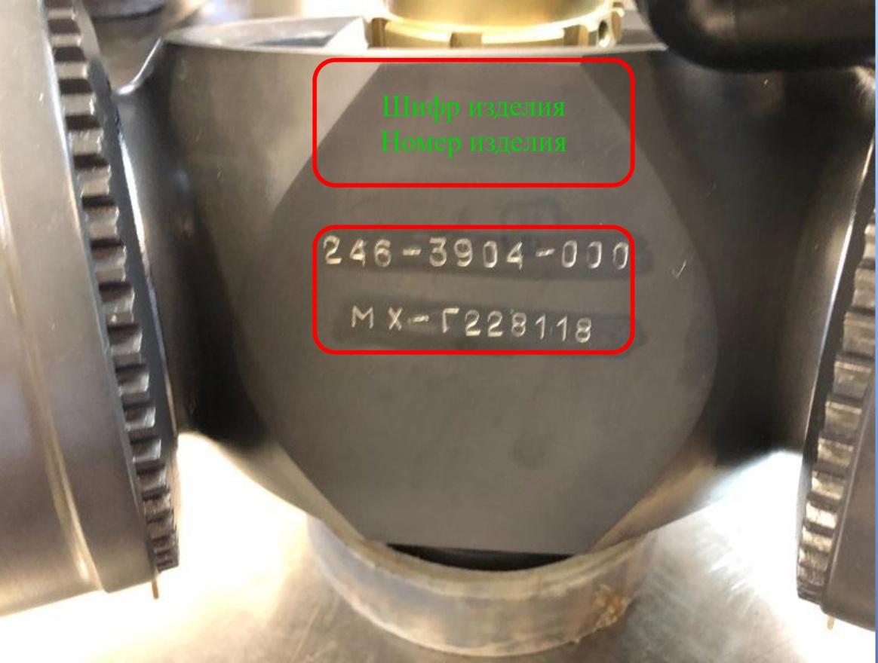
Part number
Serial number
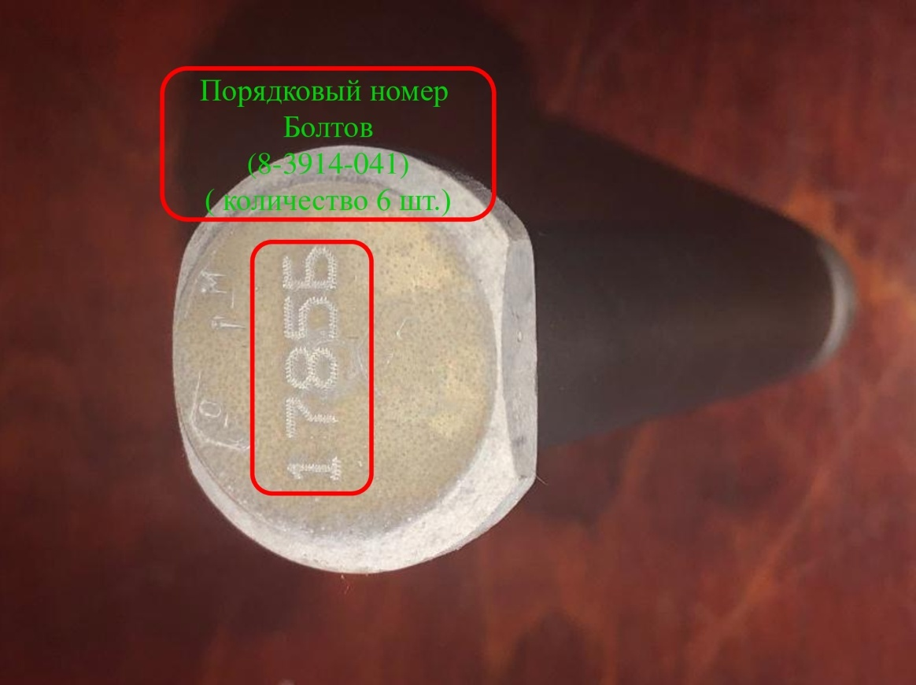
Sequence number of bolts
(quantity 6 pc.)

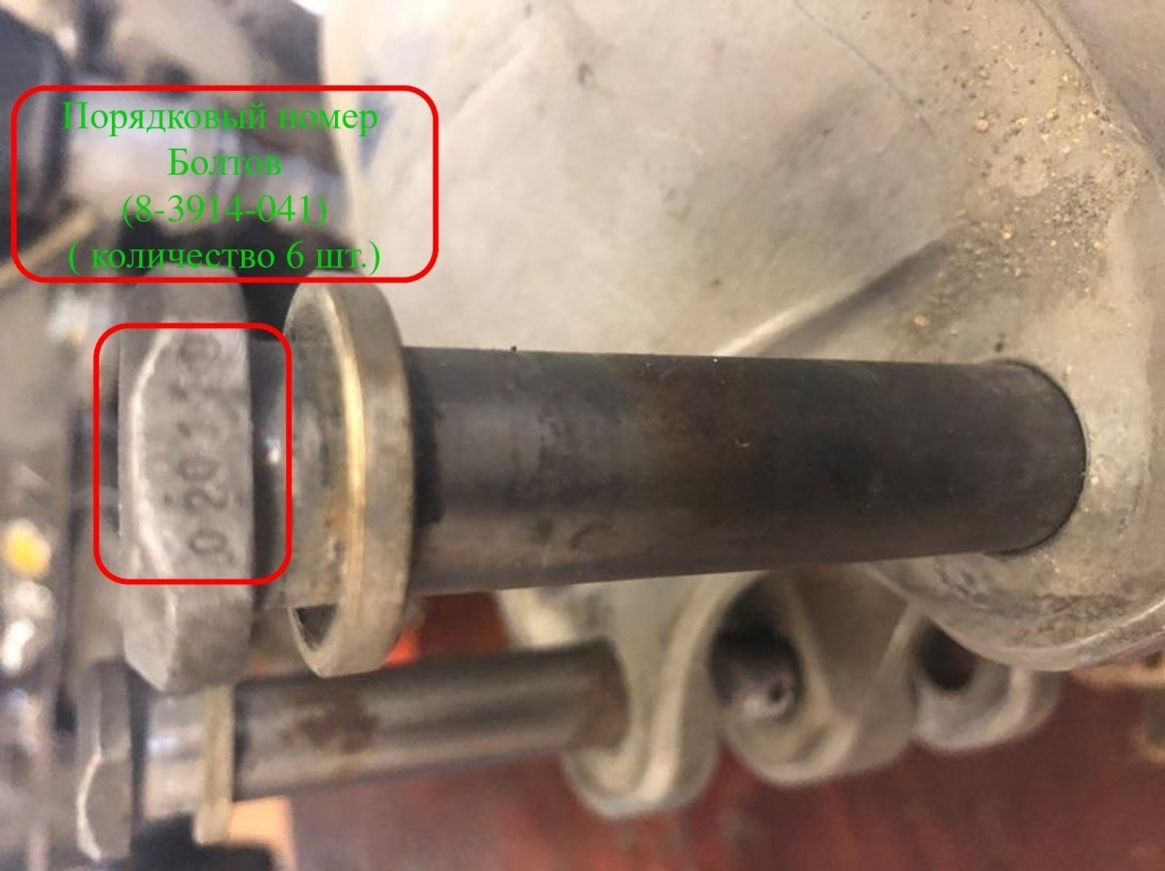
Sequence number of bolts
(quantity 6 pc.)
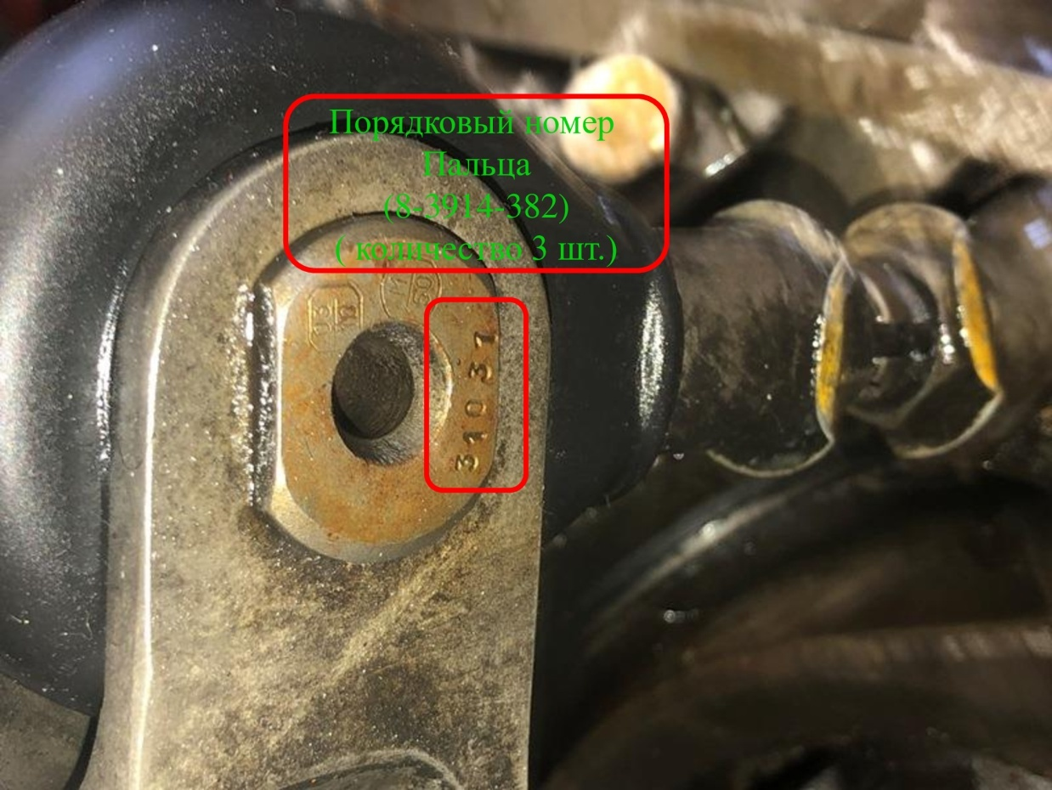
(quantity 3 pc.)
Ordinal position
of the finger

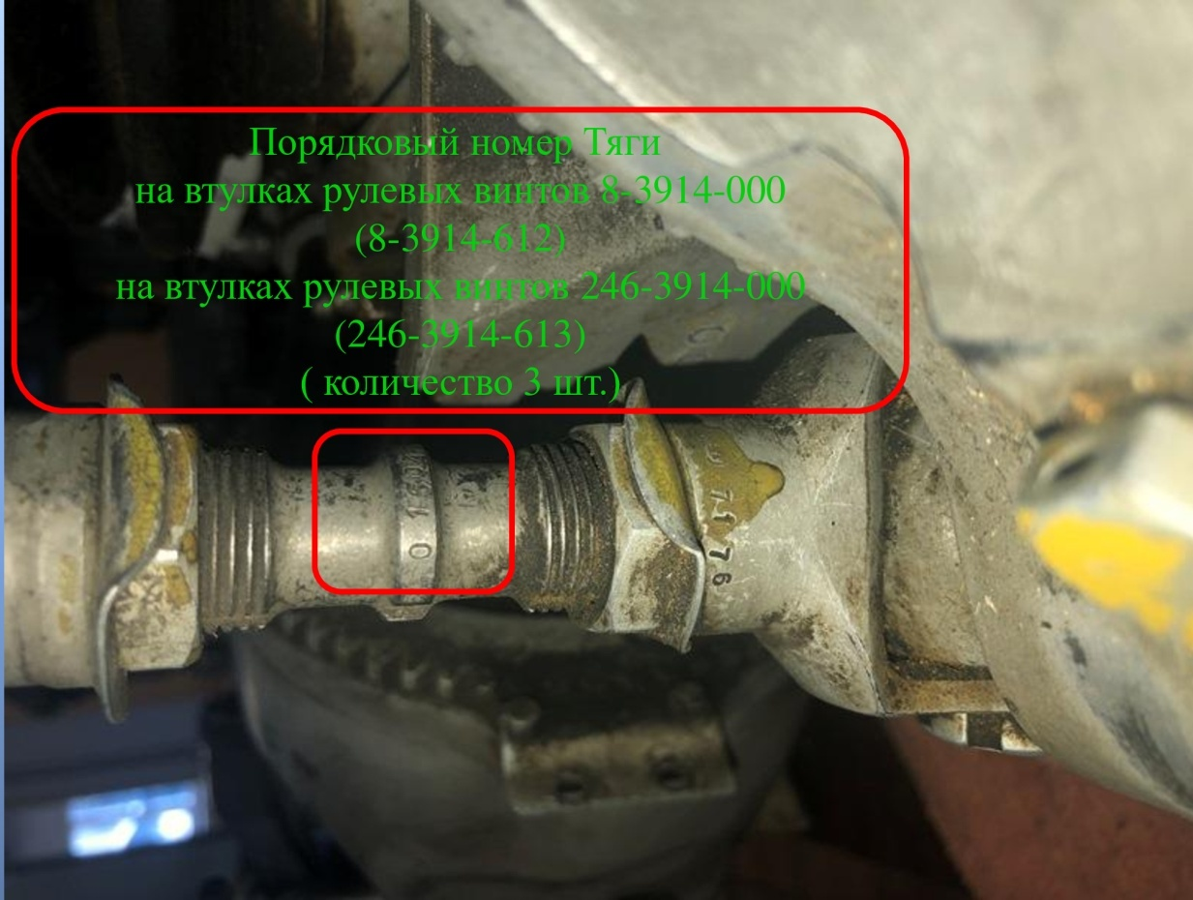
(quantity 3 pc.)
on the sleevs of tail rotors 246-3914-000
Thrust sequence number
on the sleevs of tail rotors 8-3914-000
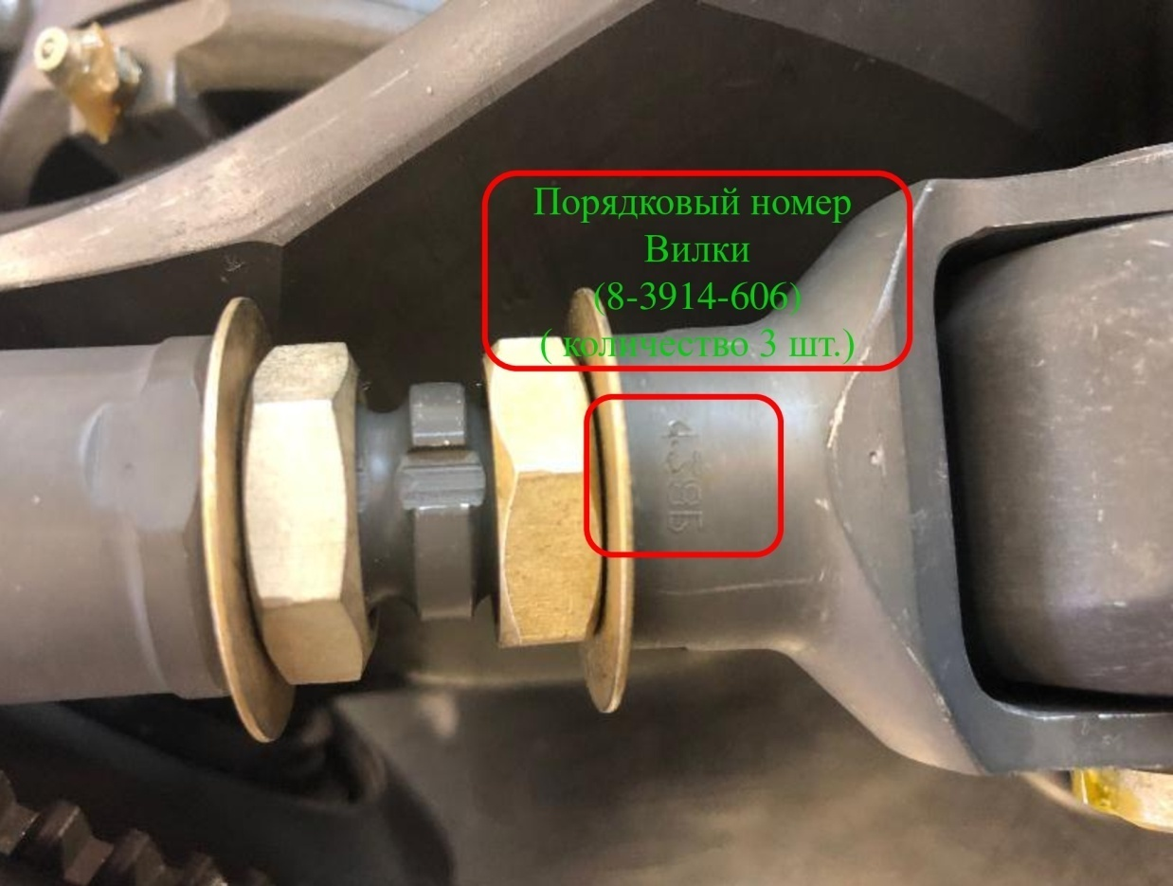
(quantity 3 pc.)
sequence number of the fork
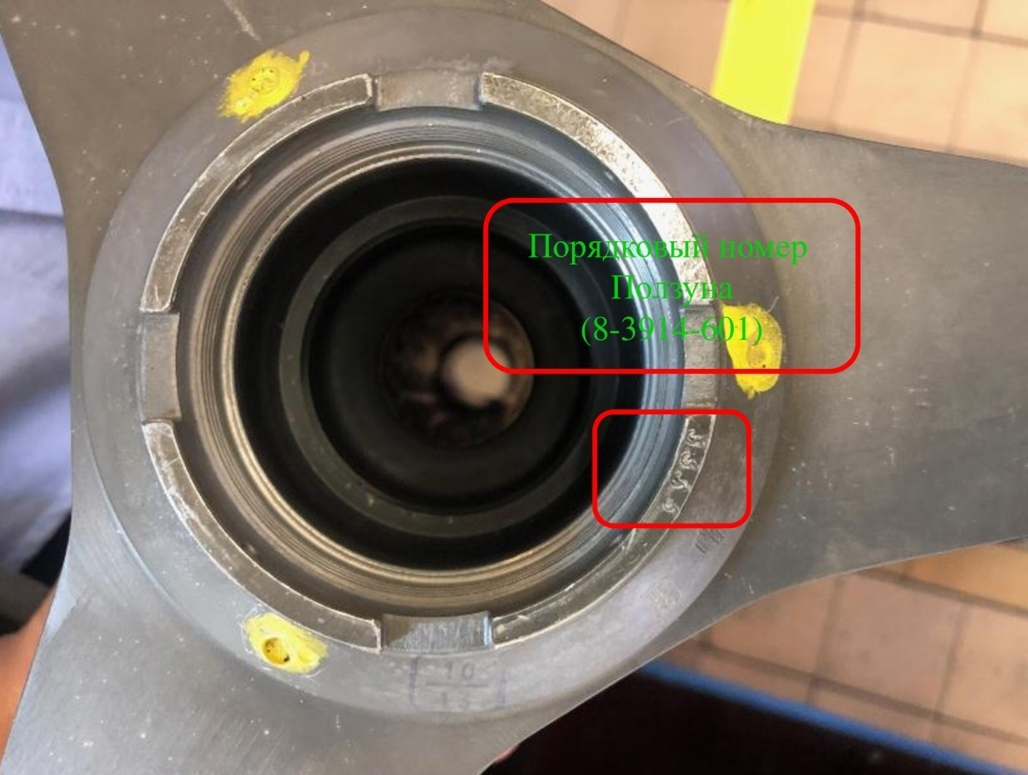
sequence number of the slide

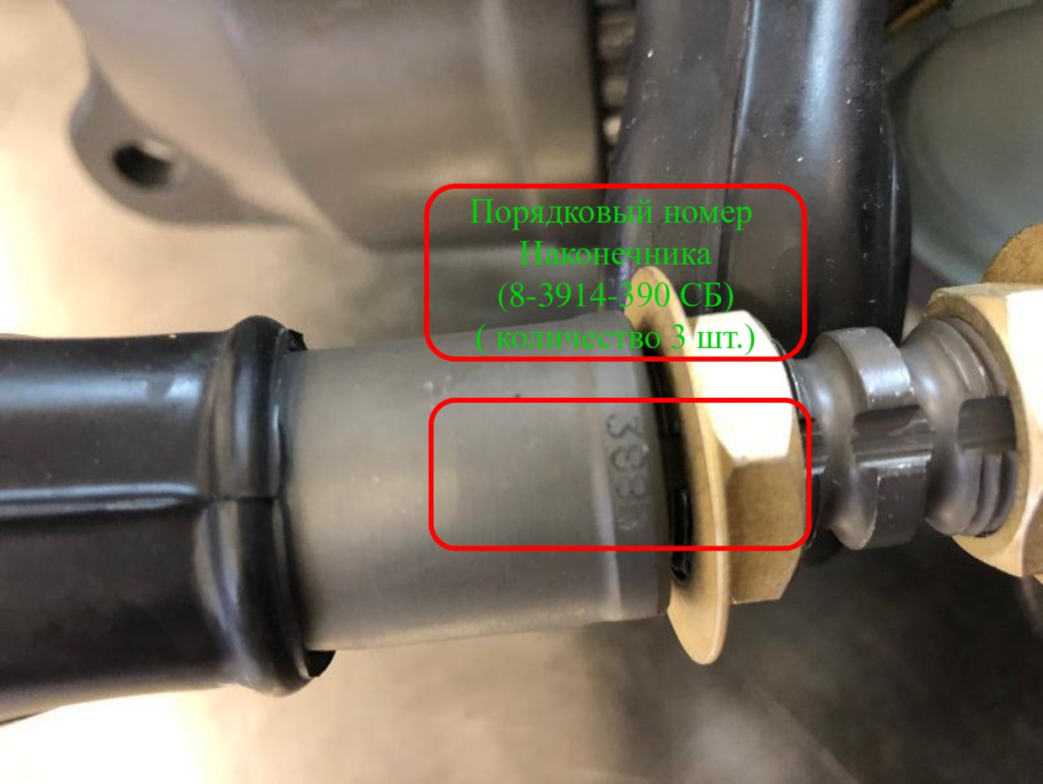
(quantity 3 pc.)
sequence number of the tip

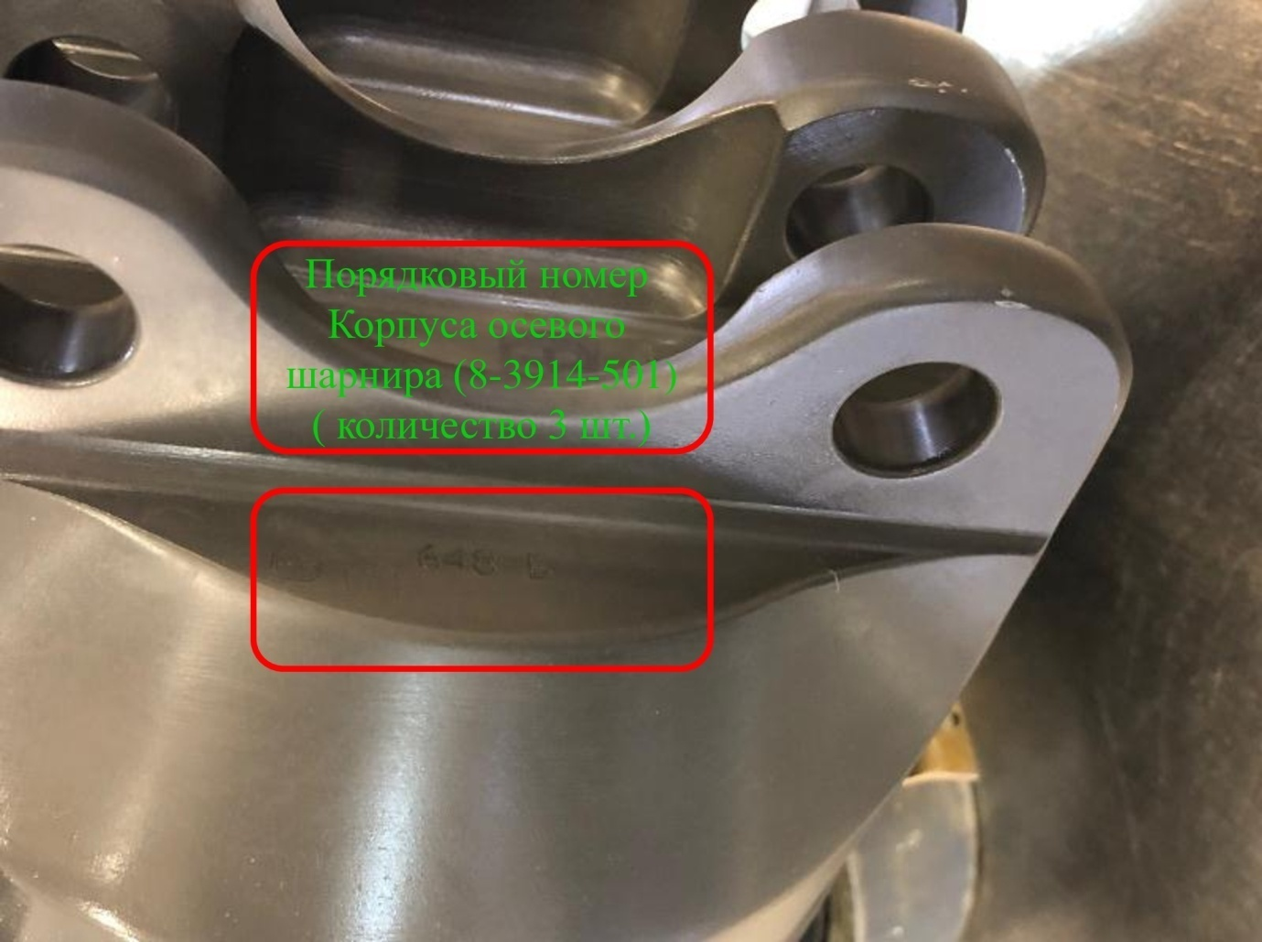
Sequence number of the
axial hinge housing
(8-3914-501)
(quantity 3 pc.)

1.8. To assess the authenticity of vibration dampers 8MT-1280-100, it is necessary to provide color images of product markings, namely:

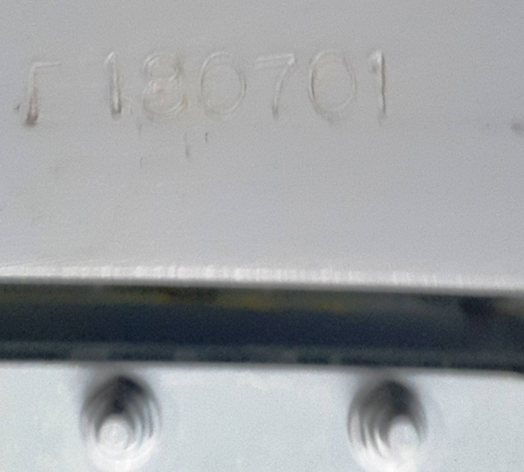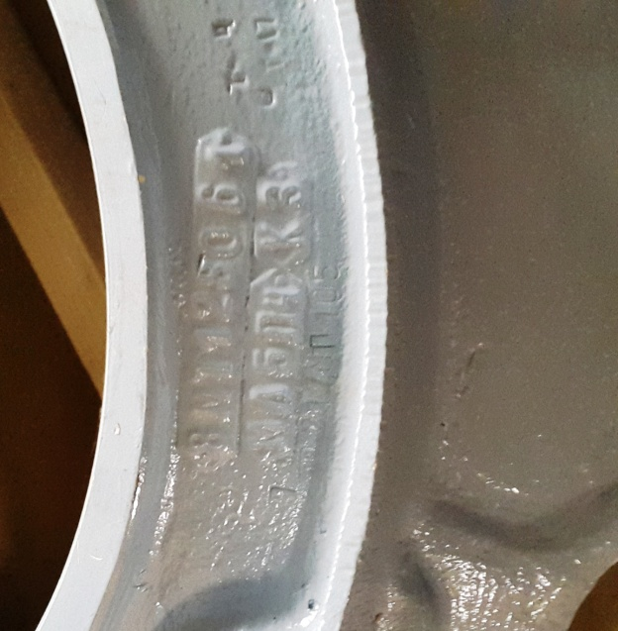

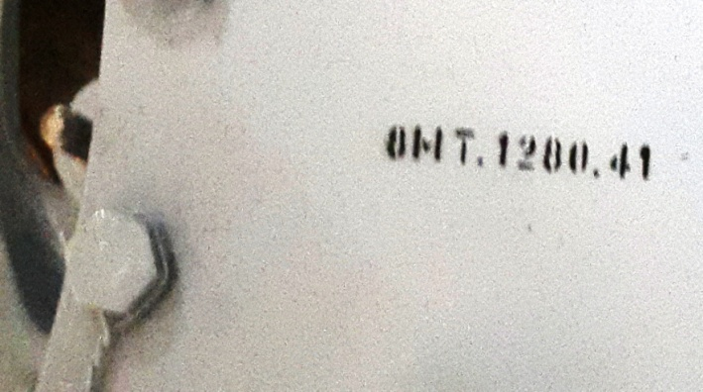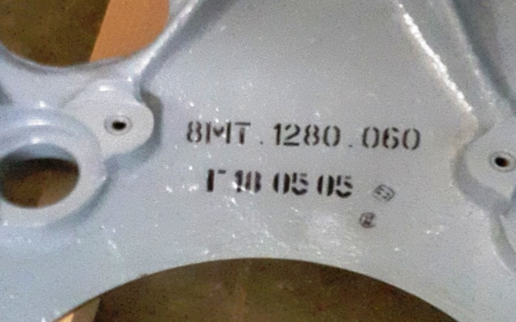

1.9. To assess the authenticity of the main gearbox VR-14, it is necessary to provide color photos of unit’s part number of main gear box VR-14, listed below:
- Screw shaft housing 7971.0609
- Screw shaft housing 7971.0609(2)
- Housing of gear box 7872.0300
- front cover 7871.4400
- cover right 7971.3040
- cover left 7874.0030
- Fan drive cover 7271.0161
- gear pan

Unit’s part number of main gear box VR-14
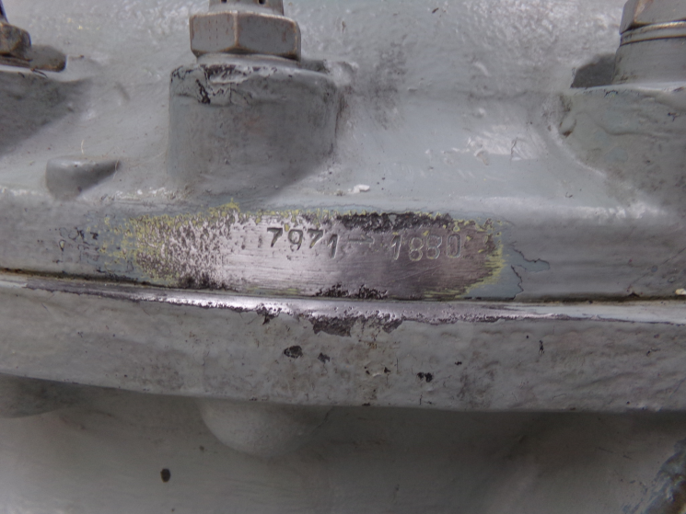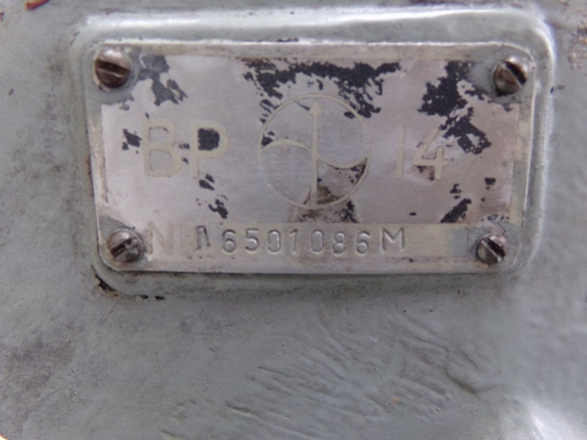
Screw shaft housing 7971.0609 Screw shaft housing 7971.0609(2)

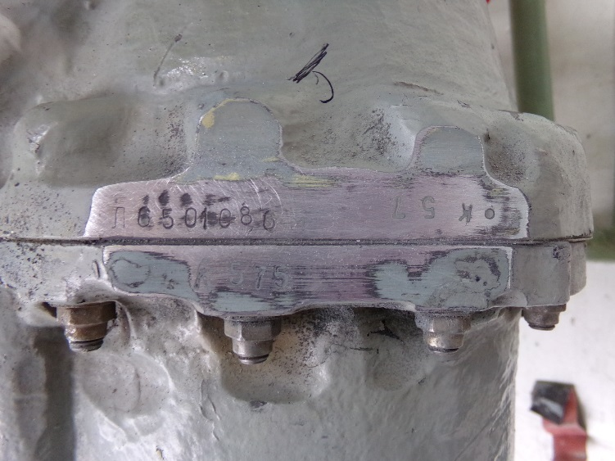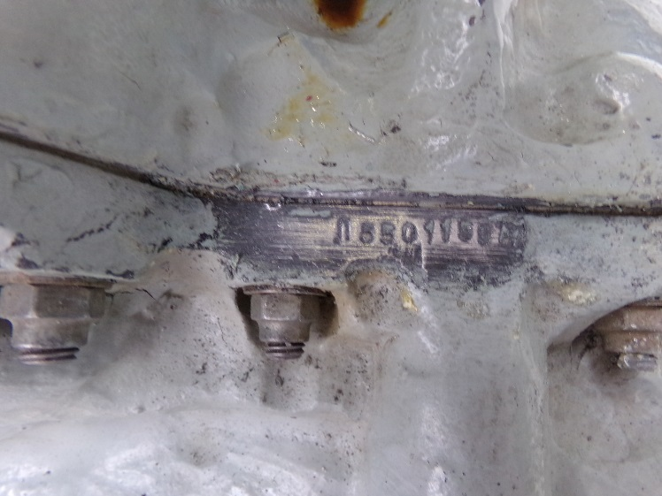
Housing of gear box 7872.0300 front cover 7871.4400
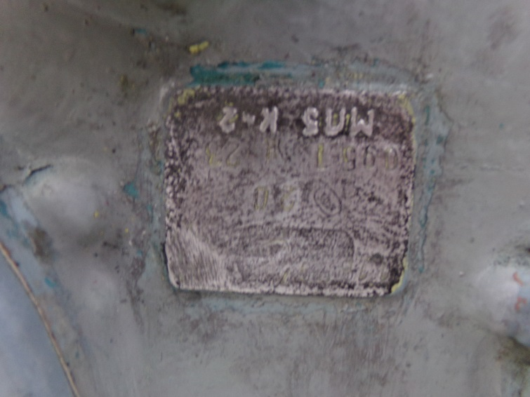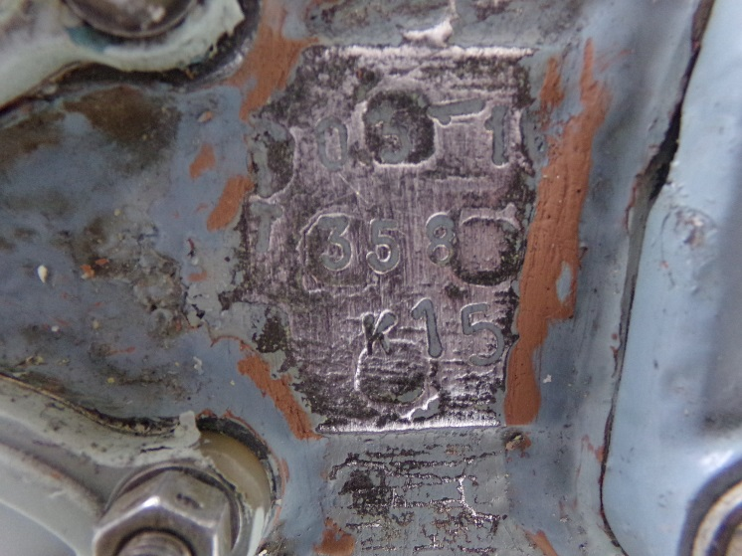
cover right 7971.3040 cover left 7874.0030

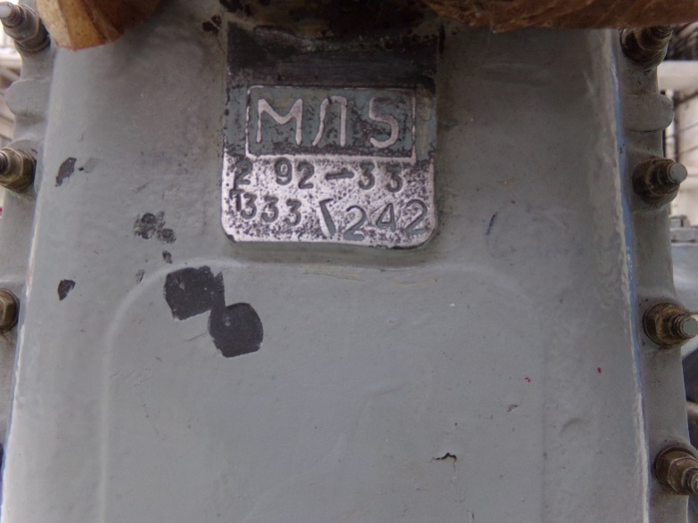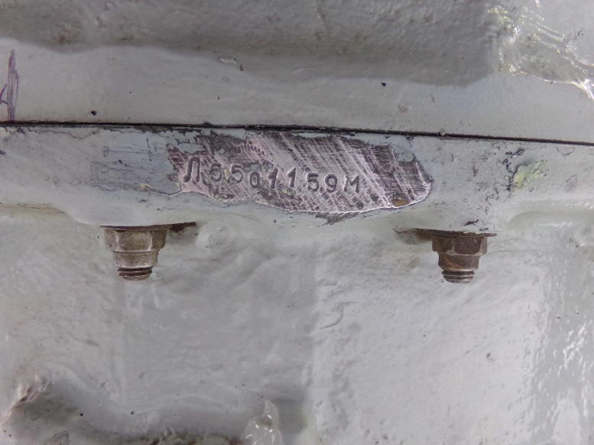

Fan drive cover 7271.0161 gear pan

Note:
Upon receipt of additional requirements on shooting individual label of components of other types, this instruction will be supplemented and will enter into force in the established order.

